Kickstarter Report

Among the conclusions that we can obtain about kickstarter campaigns are that Music and theater are the two most consistently successful kind of kickstarters there are with Film & Video being the third while others kickstarters that require a physical product or technology tend to end with more failure, such as Games, which overall has a much lower success rate.

In addition to that, it was found that success rates fall sharply from a 70% for projects that require less than $1000 down to below a 50% success rate for projects between $10k and $15k dollars. Between $10k and $45k dollars, the project goal does not seem to have a strong indication of success and failure. Success rates fall rapidly after $45k dollars down to a minimum of 16% success due to a compounded effect of reduced success and a slow but gradual increase with the goal target. This sudden spike might indicate a threshold of a combination of average donations and amount of donations.

Another conclusion that could be gathered from the data is that successful campaigns generally have a significantly higher amount of backers than unsuccessful campaigns. By looking at the histograms, it was determined that the Median was the most representative value for the each of the categories. Successful campaigns had a Median of 62 backers and unsuccessful campaigns had a median of 4. Successful campaigns had a higher variability of backers because while failed campaigns didn’t have enough backers to reach the goal, successful campaigns often had more backers than necessary to achieve their goal while unsuccessful ones are bound by an amount of backers that will not complete the goal.

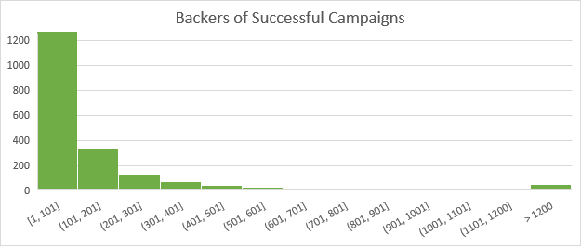

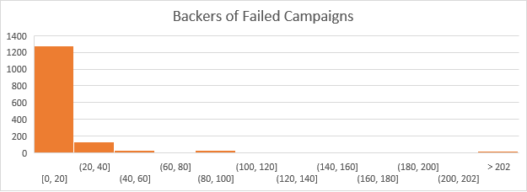

One of the main limitations of this dataset is that there is very little data on the amount individual backers donated or their region. With this data we could get more accurate data on which projects are more popular in each region based on donations and how much normalized variability each category could have. This data could greatly help in identifying to which audience to market the kickstarter to and how reliable the incoming donations would be.

One of the more useful plots or tables that can be gotten is the success rate of projects that are under the spotlight or come under Staff picks as those receive more promotion than other projects. Often times the being put in the spotlight might create enough advertising to almost guarantee a success of the project. Another possible table is to highlight the popularity of the website, seeing the total amount of projects that are started every year. This plot would be a good way to determine the popularity of the website.